**1.**

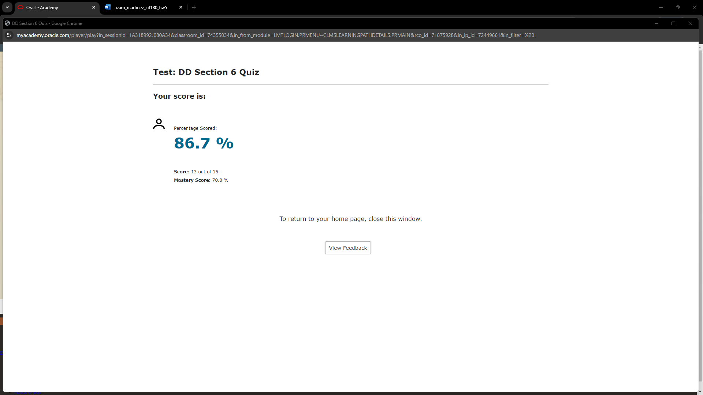

**2.**

**a.** No attribute may contain multiple values in any one instance.

**b.** Any attribute that is not a unique identifier must be dependent on the entire unique identifier

**c.** Any attribute that is not a unique identifier cannot be dependent on other non-unique identifiers

**d.** Before normalization:

STUDENT (FirstName, LastName, Course, Grade, Teacher)

**1NF** (no multi-valued attributes):

STUDENTS (PK: StudentID, FirstName, LastName)

COURSES (PK: CourseID, CourseName, Grade)

**2NF** (non-UIDs depend on the entire UID):

STUDENTS (PK: StudentID, PK: SSN, FirstName, LastName)

COURSES (PK: CourseID, CourseName, Grade, TeacherName)

**3NF** (non-UIDs cannot depend on other non-UIDs):

STUDENT (PK: StudentID, FirstName, LastName)

COURSES (PK: CourseID, CourseName, Grade)  
TEACHERS (PK: TeacherID, TeacherName)

**3.**

**a.**

Violates First Normal Form since the attribute passenger will likely be multivalued

A corrected version would be to create a new table and relate it to the existing one:  
 BUS (PK: RouteNumber, Capacity, Driver)

PASSENGER (PK: PassengerID, Name)

**b.**

Does not violate First Normal Form

**4.**

This table is in Second Normal Form because all the non-unique identifiers are functionally dependent on the UID (number).

**5.**

This table is in Second Normal Form because all non-unique identifiers (name) are fully dependent on the entire unique identifier (ID).

**6.**

storeName and storeAddress. I’m not sure if the expected answer is one or both but I know that non-UIDs depending on other non-UIDs violates 3NF.

**7.**

Violates 3NF because there are non-UIDs that depend on other non-UIDs.

Corrected:  
 CAR (PK: Number, Make, Model, ColorScheme)

COLOR (PK: ColorScheme, PaintColor, InteriorColor)

**8.**

I see two transitive dependencies (team coach on team AND agent commission on agent).